**SEIS 752 – Final Project Proposal**

**Team Members:**

* Mike Palmer
* John Stark

**Project Description:**

The website resulting from this project will provide a traveler with a way to organize their travel plans. Users will be able to create vacation itineraries. This will help them during the planning process as they assemble the pieces. It will also be a helpful tool on the vacation to reference reservation numbers and chart the progress of their trip.

**Key Features:**

Create User Account

User Login

Create New Vacation

Display Vacation

Update Existing Vacation

Delete Vacation

Store Core Information about Each Day

**Bonus Features:**

Store Addition Advanced Information

Calculate Mileage Traveled Each Day

Provide a Map Showing Route

Provide Reports about Trips

Color Code Vacation to Alert to Areas of Concern

Security Measures Beyond Basic Login

Polished UI

**User Stories:**

#1 - planning

User wants to plan a vacation. User enters each day into the system. Fills in starting city, ending city, main activity for the day, and lodging info.

#2 – vacationing

User references the app each day. Retrieves their hotel reservation info. Reviews the activities for the upcoming day.

**Mock-up of Possible Screen**

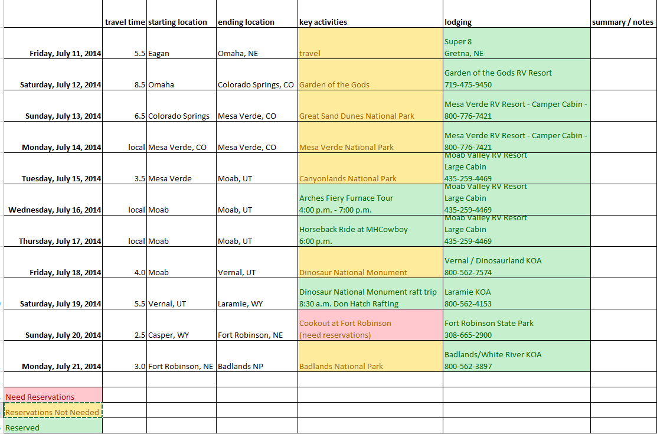

**Challenges**

Using an external API to calculate travel time between two cites by driving.

Ensuring data is validated.

Preventing security breaches.

**Project Timeline**

|  |  |  |
| --- | --- | --- |
| Event | Start Date | End Date |
| Prepare Proposal | 2/18/2015 | 3/4/2015 |
| Gather Additional Requirements | 2/25/2015 | 3/11/2015 |
| Database Table Created | 3/11/2015 | 3/18/2015 |
| Login Screen | 3/11/2015 | 3/18/2015 |
| Display Single Vacation Day | 3/11/2015 | 3/25/2015 |
| Display Multiple Vacation Days | 3/11/2015 | 4/1/2015 |
| Entry of Single Vacation Day | 4/1/2015 | 4/8/2015 |
| Entry of Multiple Vacation Days | 4/1/2015 | 4/15/2015 |
| Add, Update, Delete | 4/8/2015 | 4/22/2015 |
| Bonus Features | 4/15/2015 | 5/6/2015 |
| Testing & Fixing | 4/15/2015 | 5/12/2015 |
| Launch! |  | 5/13/2015 |

**Tentative Technology Plan**

LAMP stack

GIT

MySQL

HTML

PHP

Javascript